|  |  |  |  |
| --- | --- | --- | --- |
| **Team number** | 7 | **Section** | 3 |
| **Team Members** | 1. Jia Siang Fung 2. Brendan Chao 3. Tatsuya Hayashi | | |
| **Software Name** | Appliance Manager | | |

## Introduction

* 1. Objective

The main objective of this document is to give an overview of the technical aspects of our software. It highlights important class relationships, different scenarios between specific classes, and gives a preview of how the software would function. The intended audience for this document are the developers who are writing the code for implementation. Having a background in programming is required to understand this document.

* 1. References

7-Functional Specification, CS151-03 Lecture slides written by Ahmad Yazdankhah, 7-Problem Statement

* 1. Acronyms, and abbreviations  
     N/A

## Software overview

* 1. Problem statement

This software controls different appliances in your house that have bluetooth compatibility all from one application.

The software allows the user to add a new appliance based on the type of appliance it is. They can also choose to delete ones that have already been set up.

The user chooses the name for the appliance and the software automatically detects nearby bluetooth-compatible appliances fitting the type.

The user can choose from different functionality depending on the type of appliance they are trying to control.

For example, TVs will have functionality such as turning up and down volume, or turning it on. Air conditioners can have functionality such as adjusting the temperature. Ovens can set the timer and temperature before starting it.

The functionality will be issued through a user interface after selecting the appliance the user had already set up. This interface will be in the form of different buttons and sliders for each function that the user can interact with.

* 1. Scope

This product would target people who are looking to modernize their household with smart home technology. This product can also be used by people who are looking to make their lives more convenient and time-efficient.

* 1. Technological Requirements

Java and JavaFX are the technologies used for implementation.

Java 8, Windows 7, and Mac OS X are the minimum technological requirements that

are required to run the software.

## Detailed Design

* 1. UML Class diagrams (for all classes)

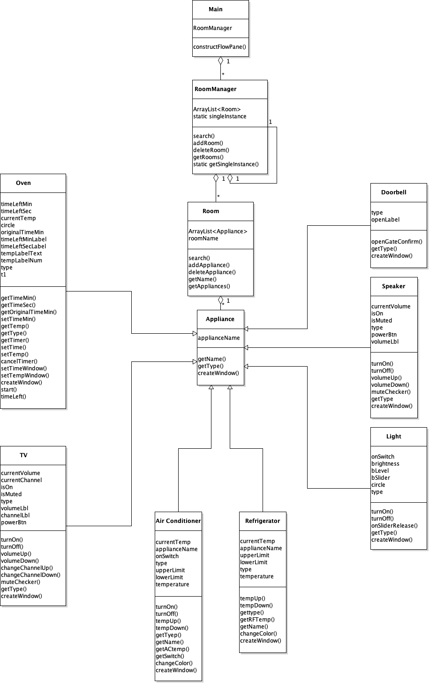

* 1. UML Sequence and/or state diagrams (at least one)

Adding an Appliance

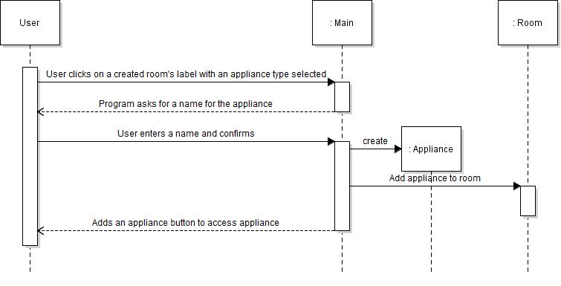

Deleting an Appliance

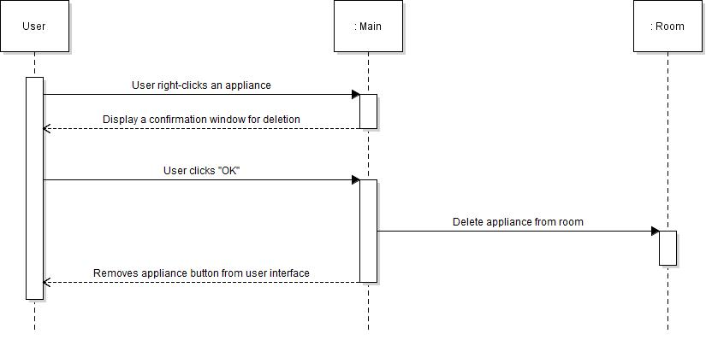

Adding a Room

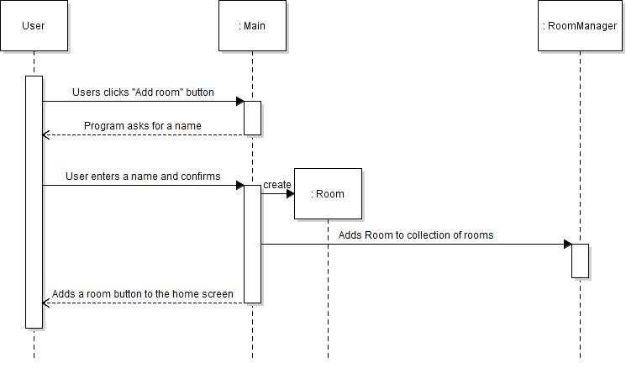

Deleting a Room

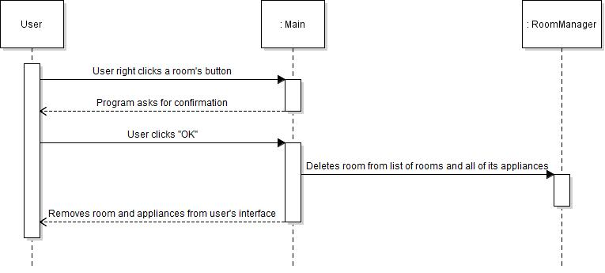

Selecting an appliance

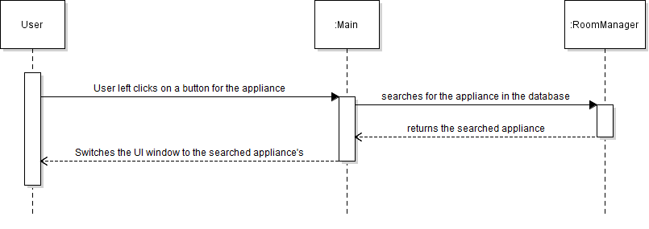

After selecting an appliance:

Light State diagram

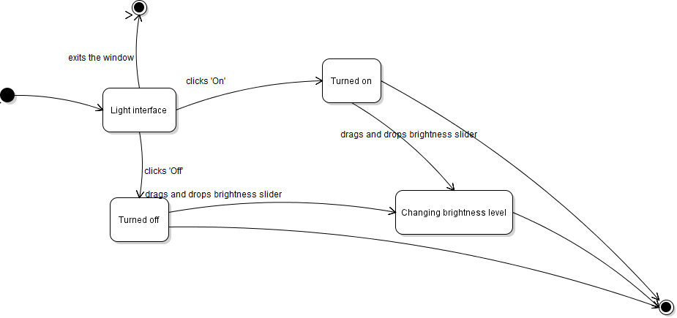

TV State Diagram

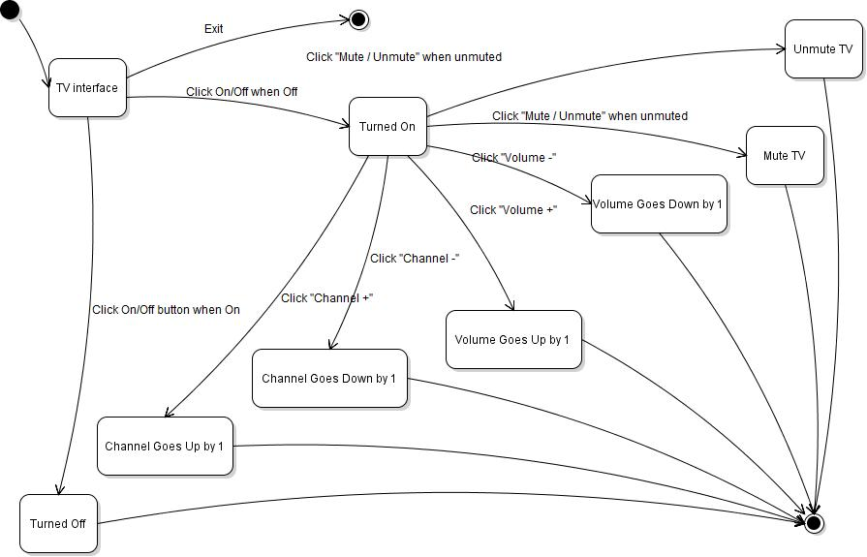

Speaker State Diagram

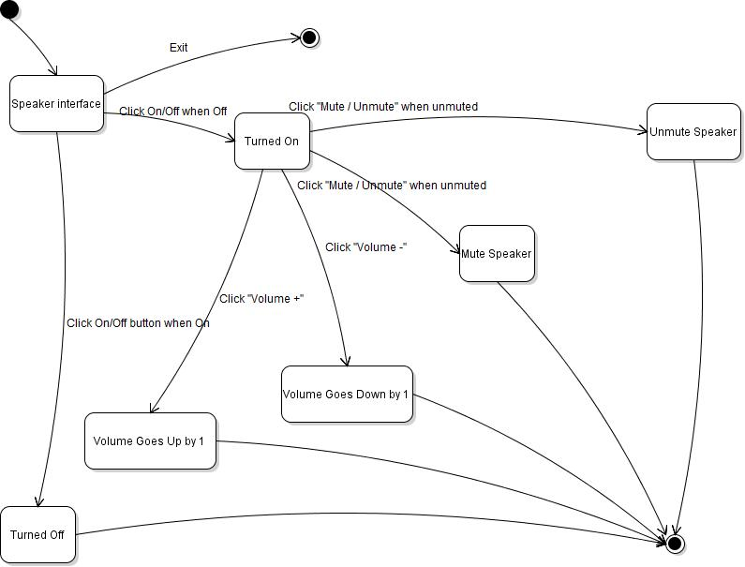

Doorbell State Diagram

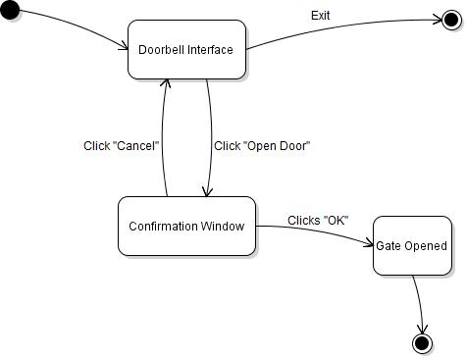

Oven State Diagram

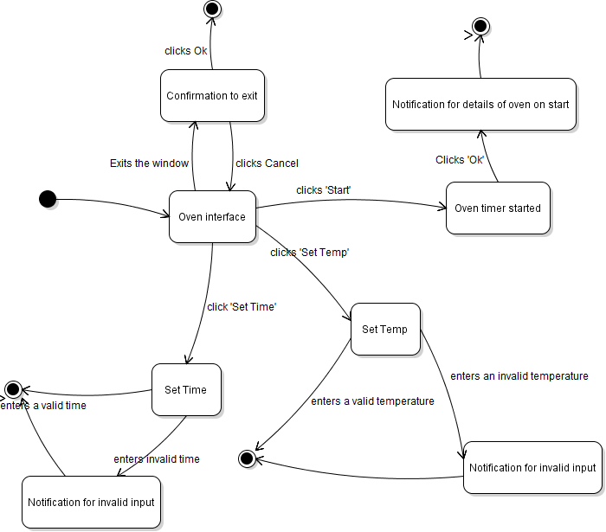

Air Conditioner State Diagram

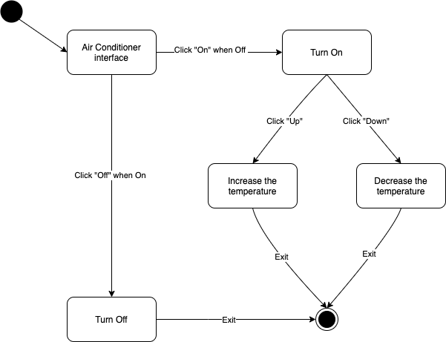

Refrigerator State Diagram

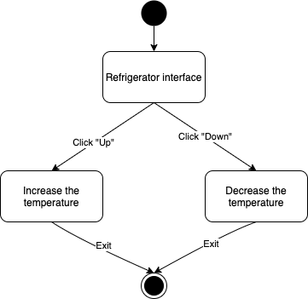

* 1. User Interface

When the user clicks on the 'Add room' button to add a room

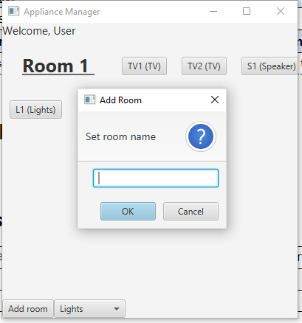

When the user left clicks a room to add an appliance

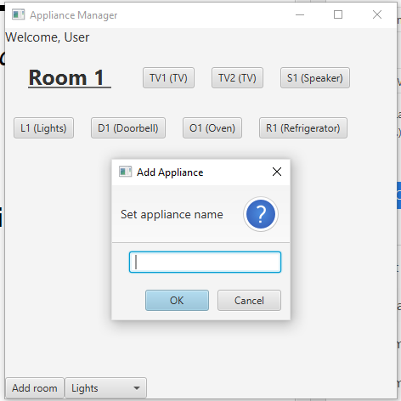

UI window for when the user clicks on an appliance of type TV

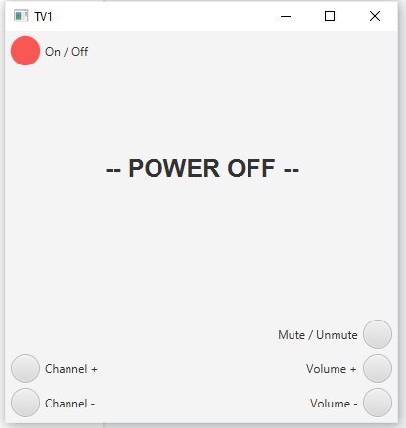

When the user clicks 'On', increases the volume to 60, and increases the channel to 5

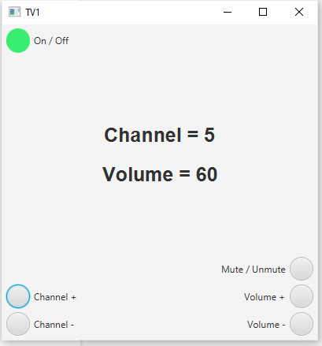

when the user clicks on 'Mute'

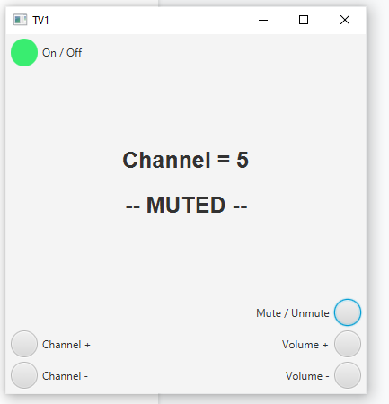

UI window for when the user clicks on an appliance of type Speaker

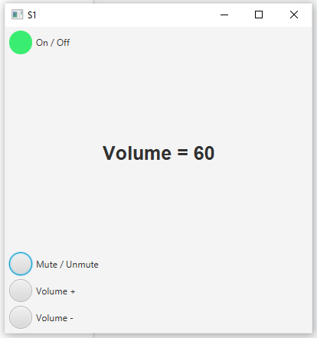

When the user clicks on 'Mute'

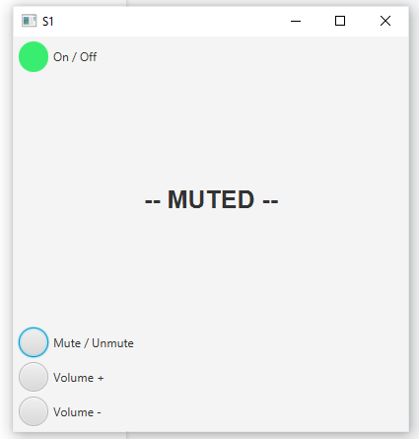

UI window for when the user clicks on an appliance of type Light

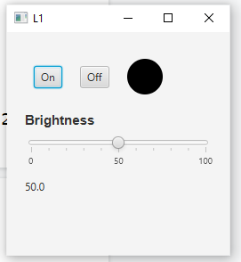

When the user clicks on 'On' while the lights are turned off

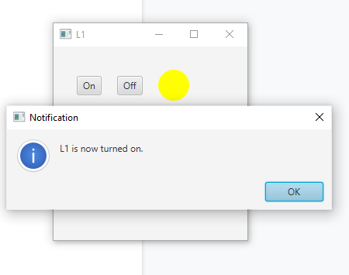

UI window for when the user clicks on an appliance of type Doorbell

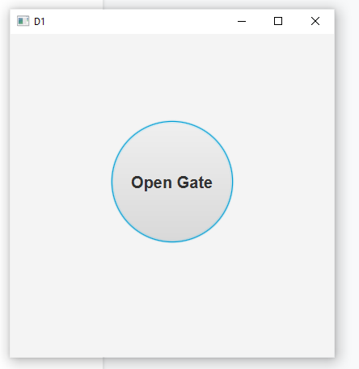

When the user clicks on 'Open Gate'

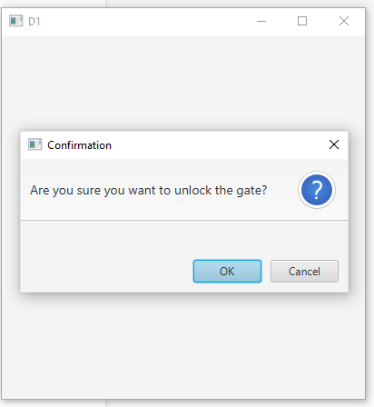

UI window for when the user clicks on an appliance of type Oven

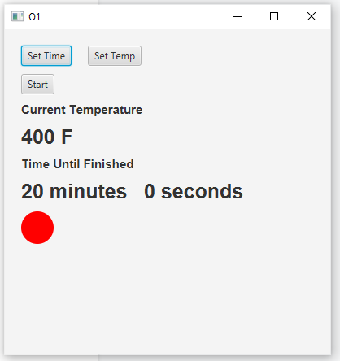

When the user clicks on 'Set Time'

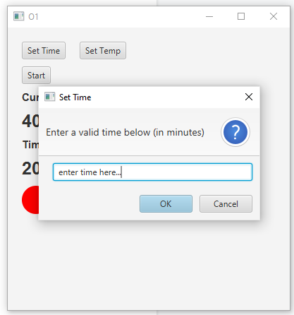

When the user clicks on 'Set Temp'

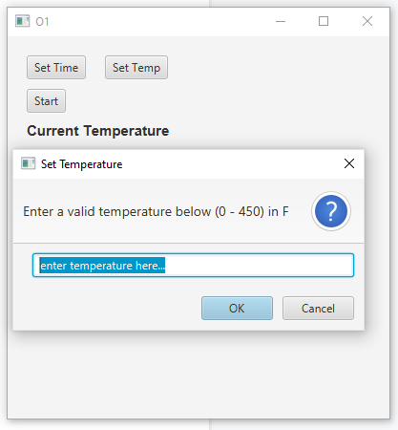

When the user clicks on 'Start'

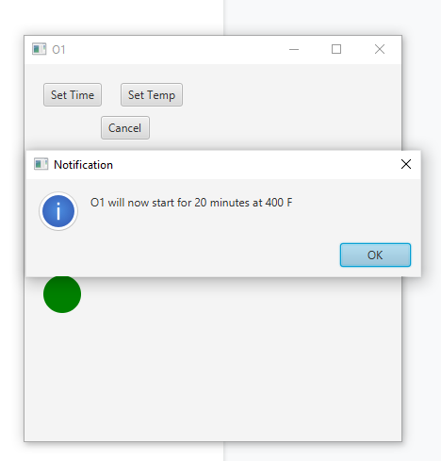

Timer counting down after the timer has started.

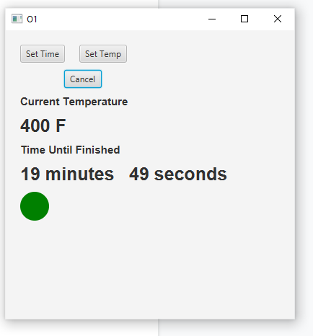

UI window for when the user clicks on an appliance of type Refrigerator

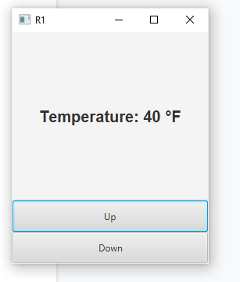

When the user left clicks on the “Up” button to increase the temperature up to 50 °F.

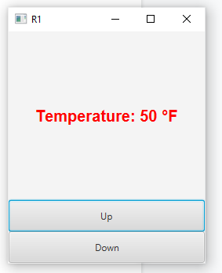

When the user left clicks on the “Down” button to decrease the temperature down to 30 °F.

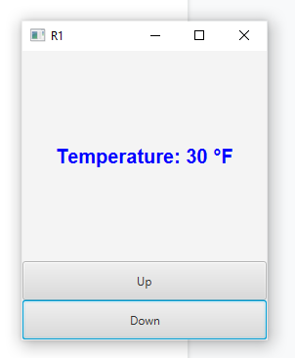

UI window for when the user clicks on an appliance of type Air conditioner

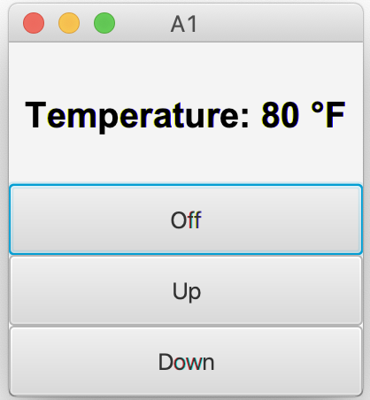

UI window for when the user clicks on an appliance of type Air conditioner

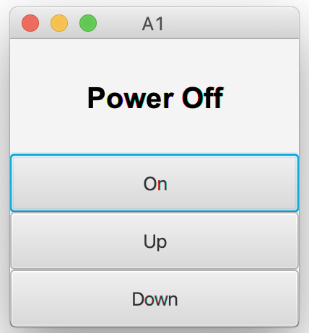

When the user clicks on “On” button

